**PROJECT 2**

**LIBRARY SYSTEMS DATABASE**

**Kennedy Donkor**

**DBST 651, Fall 2020**

**11/08/2020**

**Statement of Work**

**Overview:**

The New York Public Library, Baltimore County Library, and UMUC Library are current library systems who are looking to upgrade their current file-based system with all data stored in a single spreadsheet into a more reliable system. The current system they have in place has some major issues. Some of the issues with the file-based storage model include data redundancies, data isolation, integrity problems, security problems, and concurrency access. All of these can lead to inconsistencies in the data format and also making it difficult for information retrieval. Also, data ensuring the correctness and consistency of the data could also be a problem. Other issues include being able to have multiple users access the data at the same time and enforcing constraints to help with the data security. These are all issues that make the file-based storage model not ideal.

**Executive Summary:**

A database created for these library systems will increase efficiency, productivity, and impact of the libraries on its customers and the community at large.

Creating an electronic database will serve these library systems and its customers by making it easier to keep track of all their items. With this current system, retrieving information can be difficult and when items go missing, it is difficult to track them. With this system set up, communication within and outside the systems will have an easier time communicating amongst each other. Not a lot of storage space will be required for the project and the manpower needed to complete this project will be minimal which will bring the cost of the overall project down.

**Objectives:**

This database will help in the construction and maintenance of an online source of information for the immediate retrieval for the libraries. The customers will also be able to receive quick and accurate information on inquiring about an item. The workers in seconds will be able retrieve information for the customers in terms of what books are available and which branches currently have a copy. This project will eliminate the redundancies, data isolation, integrity problems and improve data security. With these library systems being as big as they are, concurrency access which this implementation will provide will help improve the work environment. It will be made simple enough to teach even the least tech savvy individual.

**Project Scope:**

**Include in Project Scope:**

Collecting the data requirements from the libraries

Gaining access to the current database

Installing required software

Creating Business rules

Generating the Entity-Relationship model

Creating the Data Definition Languages (DDL)

Creating the Data Manipulation Language (DML)

Performing data validation checks and the addition of constraints

**Excluded from Project Scope:**

Maintenance of the database

Using systems that are compatible with the database

Database system that is compatible with other library databases

**Database Goals, Expectations, and Deliverables:**

The goal of the database is to organize the library systems together. Organize the items in the libraries and keep track of the transactions taking place. The database is expected to have all the detailed information of the items, the customers, and the transactions taking place. There are some data anomalies with the current solution. There is an insert anomaly because no new library card can be inserted unless a customer comes in to request one. There is also a delete anomaly with Harley Cohen due to her having only one entry in the system. Once she decides to cancel her card and is deleted, every information about her will be deleted as well. There is also an update anomaly especially for the customers with multiple books checked out. If Christian Walker’s 02/20/2017 transaction address is changed it will not reflect on all of his other transactions. It would have to be individually changed as well to reflect his current address. The deliverables will include the database, the entity-attribute list, the data definition list, the data model, the DDL file.

**Database Benefits:**

The current system is in 1NF which can lead to a lot of problems. This database will improve the system and move them from 1NF to 3NF. This will be done in steps. To move into 2NF the data table will need to be partitioned into its different entities. The entities that will need to be created include a table for the customer information, library card, library, transaction, the branch, branch item, and catalogue. The entities need to be assigned their unique primary and foreign keys. After this is done, we need to ensure there are no transitive functional dependencies. To ensure this and to move it into 3NF, two more tables need to be created. The catalogue table has two items, books and DVDs. We will have to create separate tables for these two as well. This will get rid of the redundancies, the data isolation, improve data integrity, and improve data security.

**Project Hardware and Software Tools:**

This project will be completed within the Virtual Machine environment provided by University of Maryland Global Campus. The virtual environment will be accessed from a MacBook Air with macOS Catalina version 10.15.6 processor. The virtual environment PC is AUV-UMGCVDA-33. The project will also be using E-R Assistant and Oracle SQL Developer version 19.1.0.094.

**SQL Usage and Style Guide:**

Consistent and descriptive identifiers and names will be used. Example, all names will be descriptive and begin with a letter and if a name is more than one word an underscore will be used. For example, “First Name” will be written as “First_Name”. The ISO 8601 compliant date formation will be used and inputted as MM/DD/YYY. When comments are use, they will open with /* and close with */. Adequate white space will be used and statements broken up over multiple lines to make it more legible. If a comment is required after a SQL statement then “--“ will be used as the beginning of the comment. Hungarian notations will be avoided along with plurals as much as possible.

**PART 1**

1. What are some of the major issues with the current file-based storage model?

Some of the major issues with the file-based storage model include data redundancies, data isolation, integrity problems, security problems, and concurrency access. All of these can lead to inconsistencies in the data format and also making it difficult for information retrieval. Also, data ensuring the correctness and consistency of the data could also be a problem. Other issues include being able to have multiple users access the data at the same time and enforcing constraints to help with the data security. These are all issues that make the file-based storage model not ideal.

1. Are there data anomalies with the current solution? Can you provide specific examples of INSERT/UPDATE/DELETE anomaly?

There are some data anomalies with the current solution. There is an insert anomaly because no new library card can be inserted unless a customer comes in to request one. There is also a delete anomaly with Harley Cohen due to her having only one entry in the system. Once she decides to cancel her card and is deleted, every information about her will be deleted as well. There is also an update anomaly especially for the customers with multiple books checked out. If Christian Walker’s 02/20/2017 transaction address is changed it will not reflect on all of his other transactions. It would have to be individually changed as well to reflect his current address.

1. If you design your database strictly based on the current model (meaning one table to store all information), would it be considered as normalized? Would it be in 1NF, 2NF, and 3NF?

It would be considered normalized but would be in 1NF as each cell contains a single value.

1. If not, describe and illustrate the process of normalizing it to 3NF. Identify functional dependencies and create dependency diagram before each conversion.

To move into 2NF we need to partition the table into its different entities. The entities that will need to be created include a table for the customer information, library card, library, transaction, the branch, branch item, and catalogue. The entities need to be assigned their unique primary and foreign keys. After this is done, we need to ensure there are no transitive functional dependencies. To ensure this and to move it into 3NF, two more tables need to be created. The catalogue table has two items, books and DVDs. We will have to create separate tables for these two as well.

Functional Dependencies for customers:

Customer_ID-->customer_first_name, customer_last_name, customer_street, customer_city, customer_state, customer_zip

Functional Dependencies for Library card:

Library_Card_ID-->customer_ID, card_number, pin, expiration_date, library_ID

Functional Dependencies for transactions:

Transaction_ID-->checkout_date, due_date, returned_date, library_card_ID, branch_item_ID

Functional Dependencies for the library:

Library_ID🡪library_name, library_phone, library_address

Functional Dependencies for branch:

Branch_ID🡪branch_name, branch_phone, branch_address, library_ID

Functional Dependencies for branch item:

Branch_item_ID🡪branch_ID, catalog_item_ID, copy_number, purchased_date

Functional Dependencies for catalog item:

Catalog_item_ID🡪title, description, publisher, release_date, type

Functional Dependencies for book:

Catalog_item_ID🡪ISBN, pages

Functional Dependencies for DVD:

Catalog_item_ID🡪length

|  |
| --- |
| Customer ID |
| Customer First Name |
| Customer Last Name |
| Customer Street |
| Customer City |
| Customer Zip |
| Transaction ID |
| Checkout Date |
| Due Date |
| Returned Date |
| Library card ID |
| Library ID |
| Card number |
| Pin |
| Expiration date |
| Branch item ID |

|  |
| --- |
| Library ID |
| Library name |
| Library phone |
| Library address |
| Branch ID |
| Branch name |
| Branch phone |
| Branch address |
| Branch item ID |
| Catalog item ID |
| Copy number |
| Purchased date |

|  |
| --- |
| Catalog item ID |
| Title |
| Description |
| Publisher |
| Release date |
| Type |
| Book |
| ISBN |
| Pages |
| DVD |
| Length |

1. Show the final table structure after normalization and make sure it is in 3NF.

Primary keys are bolded and foreign keys are italicized.

Customers:

|  |  |  |  |  |  |  |
| --- | --- | --- | --- | --- | --- | --- |
| **Customer ID** | Customer First Name | Customer Last Name | Customer Street | Customer City | Customer State | Customer Zip |

Library Card:

|  |  |  |  |  |  |
| --- | --- | --- | --- | --- | --- |
| **Library Card ID** | *Customer ID* | Card Number | Pin | Expiration Date | *Library ID* |

Transactions:

|  |  |  |  |  |  |
| --- | --- | --- | --- | --- | --- |
| **Transaction ID** | Checkout Date | Due Date | Returned Date | *Library Card ID* | *Branch Item ID* |

Library:

|  |  |  |  |
| --- | --- | --- | --- |
| **Library ID** | Library Name | Library Phone | Library Address |

Branch:

|  |  |  |  |  |
| --- | --- | --- | --- | --- |
| **Branch ID** | Branch Name | Branch Phone | Branch Address | *Library ID* |

Branch Items:

|  |  |  |  |  |
| --- | --- | --- | --- | --- |
| **Branch Item ID** | *Branch ID* | *Catalog Item ID* | Copy Number | Purchased Date |

Catalog:

|  |  |  |  |  |  |
| --- | --- | --- | --- | --- | --- |
| **Catalog Item ID** | Title | Description | Publisher | Released Date | Type |

Books:

|  |  |  |
| --- | --- | --- |
| *Catalog Item ID* | ISBN | Pages |

DVDs:

|  |  |
| --- | --- |
| *Catalog Item ID* | Length |

**PART 2**

1. Identify entities and attributes. List entity name and attribute names for each entity.

**Customer**:

Customer ID

Customer First Name

Customer Last Name

Customer Street

Customer City

Customer State

Customer Zip

**Library Card:**

Library Card ID

Library ID

Customer ID

Card Number

PIN

Expiration Date

**Transaction:**

Transaction ID

Checkout Date

Due Date

Returned Date

Library Card ID

Branch Item ID

**Library:**

Library ID

Library Name

Library Phone

Library Address

**Branch**:

Branch ID

Branch Name

Branch Phone

Branch Address

Library ID

**Branch Item:**

Branch Item ID

Copy Number

Purchased Date

Branch ID

Catalog Item ID

**Catalog:**

Catalog Item ID

Title

Description

Publisher

Released Date

Type

**Books**:

Catalog Item ID

ISBN

Pages

**DVDs**:

Catalog Item ID

Length

1. Identify relationships among entities. List relationship type in terms of cardinality and specify business rules (e.g. 1:M between Library and Branch: a library has one or many branches; a branch belongs to one and only one library).

**Customer – Library Card:**

M:M between Customer and Library Card: a customer can have more than one library card; more than one library card can be held by a customer.

**Library – Library Card:**

1:M between Library and Library Card: a library can have many library cards; a library card can only belong to one library.

**Library Card – Transactions:**

1:M between Library Card and Transactions; a library card can be used for many transactions; each transaction must be made on one card

**Library – Branch:**

1:M between Library and Branch; a library can have many branches; each branch belongs to one library

**Branch – Branch Item:**

1:M between Branch and Branch Item; a branch can have many items in its branch; each branch item belongs to one specific branch

**Branch Item – Catalog:**

M:1 between Branch Item and Catalog; many branch items can belong to one catalog; one catalog can have many items.

**Branch Item - Transactions:**

1:M between Branch Item and Transactions; one branch item can be used in many transactions; transactions can be of only one branch item at a time

**Books – Catalog:**

1:M between Books and Catalog; a book can have many catalogs; a catalog can only be of one book

**DVDs – Catalog:**

1:M between DVDs and Catalog; a DVD can have many catalogs; a catalog can only be of one DVD

1. For each entity, identify primary key and foreign key if applicable. If you use surrogate key for PK, also specify business unique key (natural key). For FK, also specify parent entity and the matching attribute in parent entity.

**Customers:**

PK = Customer ID (Surrogate Key)

**Library Card:**

PK = Library Card ID (Surrogate Key)

FK = Customer ID (Customer ID in Customer (parent entity))

FK = Library ID (Library ID in Library (parent entity))

**Library:**

PK = Library ID (Surrogate Key)

**Transaction:**

PK = Transaction ID (Surrogate Key)

FK = Library Card ID (Library Card ID in Library Card (parent entity))

FK = Branch Item ID (Branch Item ID in Branch Item (parent entity))

**Branch:**

PK = Branch ID

FK = Library ID (Library ID in Library (parent entity))

**Branch Item:**

PK = Branch Item ID

FK = Branch ID (Branch ID in Branch (parent entity))

FK= Catalog Item ID (Catalog Item ID in Catalog (parent entity))

**Catalog:**

PK = Catalog Item ID

**Books**:

FK = Catalog Item ID (Catalog Item ID in Catalog (parent entity))

**DVDs**

FK = Catalog Item ID (Catalog Item ID in Catalog (parent entity))

1. Create ERD using crow’s foot notation using ER Assistant or Visio. The ERD should incorporate all items mentioned in 2.1, 2.2, and 2.3 (NOTE: 2.1, 2.2, and 2.3 still need to be answered separately in narrative format).

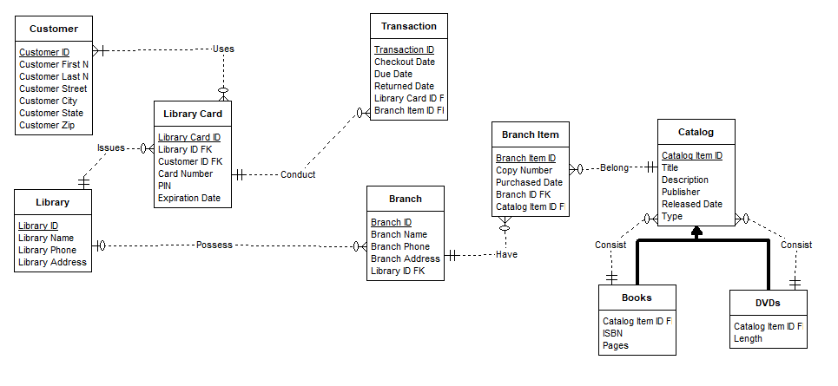

**PART 3**

/*DROP TABLE BRANCH_ITEM CASCADE CONSTRAINTS;

DROP TABLE CUSTOMER CASCADE CONSTRAINTS;

DROP TABLE LIBRARY_CARD CASCADE CONSTRAINTS;

DROP TABLE TRANSACTION CASCADE CONSTRAINTS;

DROP TABLE LIBRARY CONSTRAINTS;

DROP TABLE BRANCH CASCADE CONSTRAINTS;

DROP TABLE CATALOG CASCADE CONSTRAINTS;

DROP TABLE BOOK CASCADE CONSTRAINTS;

DROP TABLE DVD CASCADE CONSTRAINTS;

DROP SEQUENCE seq_BRANCH_ITEM_ID;

DROP SEQUENCE seq_CUSTOMER_ID;

DROP SEQUENCE seq_LIBRARY_CARD_ID;

DROP SEQUENCE seq_TRANSACTION_ID;

DROP SEQUENCE seq_LIBRARY_ID;

DROP SEQUENCE seq_BRANCH_ID;

DROP SEQUENCE seq_CATALOG_ITEM_ID;

DROP SEQUENCE seq_CATALOG_ITEM_ID;

DROP SEQUENCE seq_CATALOG_ITEM_ID;

*/

--CUSTOMERS INFORMATION--

CREATE TABLE CUSTOMER(CUSTOMER_ID NUMERIC PRIMARY KEY,

FIRST_NAME VARCHAR(30) NOT NULL,

LAST_NAME VARCHAR(30) NOT NULL,

STREET VARCHAR(100) NOT NULL,

CITY VARCHAR(50) NOT NULL,

STATE VARCHAR(2) NOT NULL,

ZIP NUMERIC(5) NOT NULL);

--LIBRARY INFORMATION--

CREATE TABLE LIBRARY(LIBRARY_ID NUMERIC PRIMARY KEY,

NAME VARCHAR(30) NOT NULL,

PHONE NUMERIC(20) NOT NULL,

ADDRESS VARCHAR(100) NOT NULL);

--LIBRARY CARD INFORMATION--

CREATE TABLE LIBRARY_CARD(LIBRARY_CARD_ID NUMERIC PRIMARY KEY,

CARD_NUMBER NUMERIC NOT NULL,

PIN NUMERIC(6) NOT NULL,

EXPIRATION_DATE DATE NOT NULL,

CUSTOMER_ID NUMERIC NOT NULL,

LIBRARY_ID NUMERIC NOT NULL,

CONSTRAINT FK_CUSTOMER_ID FOREIGN KEY(CUSTOMER_ID) REFERENCES CUSTOMER(CUSTOMER_ID),

CONSTRAINT FK_LIBRARY_ID FOREIGN KEY(LIBRARY_ID) REFERENCES LIBRARY(LIBRARY_ID));

CREATE INDEX IX_LIBRARY_CARD_CUSTOMER_ID ON LIBRARY_CARD(CUSTOMER_ID);

CREATE INDEX IX_LIBRARY_CARD_LIBRARY_ID ON LIBRARY_CARD(LIBRARY_ID);

--BRANCHES THAT THE LIBRARY OWN--

CREATE TABLE BRANCH(BRANCH_ID NUMERIC PRIMARY KEY,

NAME VARCHAR(30) NOT NULL,

PHONE NUMERIC(20) NOT NULL,

ADDRESS VARCHAR(100) NOT NULL,

LIBRARY_ID NUMERIC NOT NULL,

CONSTRAINT FK_BRANCH_LIBRARY_ID FOREIGN KEY(LIBRARY_ID) REFERENCES LIBRARY(LIBRARY_ID));

CREATE INDEX IX_BRANCH_LIBRARY_ID ON BRANCH(LIBRARY_ID);

--THE CATALOG IN EACH LIBRARY BRANCH--

CREATE TABLE CATALOG(CATALOG_ITEM_ID NUMERIC PRIMARY KEY,

TITLE VARCHAR(50) NOT NULL,

DESCRIPTION VARCHAR(50) NOT NULL,

PUBLISHER VARCHAR(30) NOT NULL,

RELEASED_DATE DATE NOT NULL,

TYPEY VARCHAR(30) NOT NULL);

--ITEMS FOUND IN EACH BRANCH--

CREATE TABLE BRANCH_ITEM(BRANCH_ITEM_ID NUMERIC PRIMARY KEY,

COPY_NUMBER NUMERIC NOT NULL,

PURCHASED_DATE DATE NOT NULL,

BRANCH_ID NUMERIC NOT NULL,

CATALOG_ITEM_ID NUMERIC NOT NULL,

CONSTRAINT FK_BRANCH_ID FOREIGN KEY(BRANCH_ID) REFERENCES BRANCH(BRANCH_ID),

CONSTRAINT FK_BRANCH_CATALOG_ITEM_ID FOREIGN KEY(CATALOG_ITEM_ID) REFERENCES CATALOG(CATALOG_ITEM_ID));

CREATE INDEX IX_BRANCH_ITEM_BRANCH_ID ON BRANCH_ITEM(BRANCH_ID);

CREATE INDEX IX_BRANCH_ITEM_CATALOG_ITEM_ID ON BRANCH_ITEM(CATALOG_ITEM_ID);

--TRANSACTIONS MADE USING A LIBRARY CARD--

CREATE TABLE TRANSACTION(TRANSACTION_ID NUMERIC NOT NULL,

CHECKOUT_DATE DATE NOT NULL,

DUE_DATE DATE NOT NULL,

RETURNED_DATE DATE ,

LIBRARY_CARD_ID NUMERIC NOT NULL,

BRANCH_ITEM_ID NUMERIC NOT NULL,

CONSTRAINT FK_TRANSACTION_LIBRARY_CARD_ID FOREIGN KEY(LIBRARY_CARD_ID) REFERENCES LIBRARY_CARD(LIBRARY_CARD_ID),

CONSTRAINT FK_BRANCH_ITEM_ID FOREIGN KEY(BRANCH_ITEM_ID) REFERENCES BRANCH_ITEM(BRANCH_ITEM_ID));

CREATE INDEX IX_TRANSACTION_LIBRARY_CARD_ID ON TRANSACTION(LIBRARY_CARD_ID);

CREATE INDEX IX_TRANSACTION_BRANCH_ITEM_ID ON TRANSACTION(BRANCH_ITEM_ID);

--CATALOG OF BOOKS--

CREATE TABLE BOOKS(CATALOG_ITEM_ID NUMERIC NOT NULL,

ISBN VARCHAR(30) NOT NULL,

PAGES NUMERIC NOT NULL,

CONSTRAINT FK_CATALOG_BOOK FOREIGN KEY(CATALOG_ITEM_ID) REFERENCES CATALOG(CATALOG_ITEM_ID));

CREATE INDEX IX_BOOKS_CATALOG_ITEM_ID ON BOOKS(CATALOG_ITEM_ID);

--CATALOG OF DVDS--

CREATE TABLE DVDS(CATALOG_ITEM_ID NUMERIC NOT NULL,

LENGTH VARCHAR(30) NOT NULL,

CONSTRAINT FK_CATALOG_DVD FOREIGN KEY(CATALOG_ITEM_ID) REFERENCES CATALOG(CATALOG_ITEM_ID));

CREATE INDEX IX_DVDS_CATALOG_ITEM_ID ON DVDS(CATALOG_ITEM_ID);

CREATE SEQUENCE CUSTOMER_ID;

CREATE SEQUENCE BRANCH_ID;

CREATE SEQUENCE LIBRARY_CARD_ID;

CREATE SEQUENCE LIBRARY_ID;

CREATE SEQUENCE TRANSACTION_ID;

CREATE SEQUENCE BRANCH_ITEM_ID;

CREATE SEQUENCE CATALOG_ITEM_ID;

INSERT INTO CUSTOMER(CUSTOMER_ID, FIRST_NAME, LAST_NAME, STREET, CITY, STATE, ZIP)

VALUES(1, 'Christian', 'Walker', '96 Clark Drive', 'Hicksvile', 'NY', '11801');

INSERT INTO CUSTOMER(CUSTOMER_ID, FIRST_NAME, LAST_NAME, STREET, CITY, STATE, ZIP)

VALUES(2, 'Deena', 'Pilgrim', '838 Orange Street', 'Frederick', 'MD', '21701');

INSERT INTO CUSTOMER(CUSTOMER_ID, FIRST_NAME, LAST_NAME, STREET, CITY, STATE, ZIP)

VALUES(3, 'Calista', 'Secor', '9330 El Dorado Lane', 'Temple Hills', 'MD', '20748');

INSERT INTO CUSTOMER(CUSTOMER_ID, FIRST_NAME, LAST_NAME, STREET, CITY, STATE, ZIP)

VALUES(4, 'Emile', 'Cross', '387 Circle Ave', 'Vincentown', 'NJ', '08088');

INSERT INTO CUSTOMER(CUSTOMER_ID, FIRST_NAME, LAST_NAME, STREET, CITY, STATE, ZIP)

VALUES(5, 'Johnny', 'Royalle', '9948 Campfire Drive', 'East Elmhurst', 'NY', '11369');

INSERT INTO CUSTOMER(CUSTOMER_ID, FIRST_NAME, LAST_NAME, STREET, CITY, STATE, ZIP)

VALUES(6, 'Harley', 'Cohen', '96 Vine Street', 'Bowie', 'MD', '20715');

INSERT INTO LIBRARY(LIBRARY_ID, NAME, PHONE, ADDRESS)

VALUES(1, 'New York Public Library', '2125551234', '476 5th Avenue, New York, NY');

INSERT INTO LIBRARY(LIBRARY_ID, NAME, PHONE, ADDRESS)

VALUES(2, 'Baltimore County Library', '4435553456', '320 York Road, Towson, MD');

INSERT INTO LIBRARY(LIBRARY_ID, NAME, PHONE, ADDRESS)

VALUES(3, 'UMUC Library', '2406842020', '1616 McCormick Dr, Largo, MD');

INSERT INTO LIBRARY_CARD(LIBRARY_ID, CUSTOMER_ID, LIBRARY_CARD_ID, CARD_NUMBER, PIN, EXPIRATION_DATE)

VALUES(1, 1, 1, '16777216', '1234', TO_DATE('12/31/2019', 'MM/DD/YYYY'));

INSERT INTO LIBRARY_CARD(LIBRARY_ID, CUSTOMER_ID, LIBRARY_CARD_ID, CARD_NUMBER, PIN, EXPIRATION_DATE)

VALUES(1, 4, 2, '33554432', '8192', TO_DATE('07/04/2020', 'MM/DD/YYYY'));

INSERT INTO LIBRARY_CARD(LIBRARY_ID, CUSTOMER_ID, LIBRARY_CARD_ID, CARD_NUMBER, PIN, EXPIRATION_DATE)

VALUES(2, 2, 3, '10485760', '8888', TO_DATE('02/29/2020', 'MM/DD/YYYY'));

INSERT INTO LIBRARY_CARD(LIBRARY_ID, CUSTOMER_ID, LIBRARY_CARD_ID, CARD_NUMBER, PIN, EXPIRATION_DATE)

VALUES(2, 3, 4, '20971520', '0911', TO_DATE('05/17/2021', 'MM/DD/YYYY'));

INSERT INTO LIBRARY_CARD(LIBRARY_ID, CUSTOMER_ID, LIBRARY_CARD_ID, CARD_NUMBER, PIN, EXPIRATION_DATE)

VALUES(3, 6, 5, '65536128', '4711', TO_DATE('10/09/2019', 'MM/DD/YYYY'));

INSERT INTO LIBRARY_CARD(LIBRARY_ID, CUSTOMER_ID, LIBRARY_CARD_ID, CARD_NUMBER, PIN, EXPIRATION_DATE)

VALUES(3, 5, 6, '32768256', '8008', TO_DATE('03/11/2020', 'MM/DD/YYYY'));

INSERT INTO LIBRARY_CARD(LIBRARY_ID, CUSTOMER_ID, LIBRARY_CARD_ID, CARD_NUMBER, PIN, EXPIRATION_DATE)

VALUES(3, 4, 7, '16384512', '8192', TO_DATE('02/15/2020', 'MM/DD/YYYY'));

INSERT INTO BRANCH(BRANCH_ID, NAME, PHONE, ADDRESS, LIBRARY_ID)

VALUES(101, '125th Street Library', '2125552345', '224 E 125th St, New York, NY', 1);

INSERT INTO BRANCH(BRANCH_ID, NAME, PHONE, ADDRESS, LIBRARY_ID)

VALUES(102, 'Grand Central Library', '2125553456', '135 E 46th St, New York, NY', 1);

INSERT INTO BRANCH(BRANCH_ID, NAME, PHONE, ADDRESS, LIBRARY_ID)

VALUES(201, 'Essex Branch', '4435554567', '1100 Eastern Blvd, Essex, MD', 2);

INSERT INTO BRANCH(BRANCH_ID, NAME, PHONE, ADDRESS, LIBRARY_ID)

VALUES(202, 'Woodlawn Branch', '4435555678', '1811 Woodlawn Dr, Woodlawn, MD', 2);

INSERT INTO BRANCH(BRANCH_ID, NAME, PHONE, ADDRESS, LIBRARY_ID)

VALUES(301, 'UMUC Library Largo', '2406842020', '1616 McCormick Dr, Largo, MD', 3);

INSERT INTO BRANCH(BRANCH_ID, NAME, PHONE, ADDRESS, LIBRARY_ID)

VALUES(302, 'McKeldin Library', '3014059046', 'UMD, College Park, MD', 3);

INSERT INTO CATALOG(CATALOG_ITEM_ID, TITLE, DESCRIPTION, PUBLISHER, RELEASED_DATE, TYPE)

VALUES(1, 'Way of Kings', 'Fantasy', 'Tor Books', TO_DATE('08/31/2010', 'MM/DD/YYYY'), 'BOOK');

INSERT INTO CATALOG(CATALOG_ITEM_ID, TITLE, DESCRIPTION, PUBLISHER, RELEASED_DATE, TYPE)

VALUES(2, 'Words of Radiance', 'Fantasy', 'Tor Books', TO_DATE('03/04/2014', 'MM/DD/YYYY'), 'BOOK');

INSERT INTO CATALOG(CATALOG_ITEM_ID, TITLE, DESCRIPTION, PUBLISHER, RELEASED_DATE, TYPE)

VALUES(3, 'Inception', 'Science Fiction/Thriller', 'Warner Bros', TO_DATE('07/08/2010', 'MM/DD/YYYY'), 'DVD');

INSERT INTO CATALOG(CATALOG_ITEM_ID, TITLE, DESCRIPTION, PUBLISHER, RELEASED_DATE, TYPE)

VALUES(4, 'Infinite Jest', 'Tragicomedy', 'Brown, Little, and Co.', TO_DATE('02/01/1996', 'MM/DD/YYYY'), 'BOOK');

INSERT INTO CATALOG(CATALOG_ITEM_ID, TITLE, DESCRIPTION, PUBLISHER, RELEASED_DATE, TYPE)

VALUES(5, 'La La Land', 'Musical', 'Summit Entertainment', TO_DATE('12/09/2016', 'MM/DD/YYYY'), 'DVD');

INSERT INTO CATALOG(CATALOG_ITEM_ID, TITLE, DESCRIPTION, PUBLISHER, RELEASED_DATE, TYPE)

VALUES(6, 'Moonrise Kingdom', 'Drama Comedy', 'Focus Features', TO_DATE('05/25/2012', 'MM/DD/YYYY'), 'DVD');

INSERT INTO CATALOG(CATALOG_ITEM_ID, TITLE, DESCRIPTION, PUBLISHER, RELEASED_DATE, TYPE)

VALUES(7, 'The Name of the Wind', 'Fantasy', 'DAW Books', TO_DATE('03/27/2007', 'MM/DD/YYYY'), 'BOOK');

INSERT INTO CATALOG(CATALOG_ITEM_ID, TITLE, DESCRIPTION, PUBLISHER, RELEASED_DATE, TYPE)

VALUES(8, 'The Social Network', 'Drama', 'Columbia Pictures', TO_DATE('10/01/2010', 'MM/DD/YYYY'), 'DVD');

INSERT INTO BOOKS(CATALOG_ITEM_ID, ISBN, PAGES)

VALUES(1, '9780765365279', 1280);

INSERT INTO BOOKS(CATALOG_ITEM_ID, ISBN, PAGES)

VALUES(2, '9780765365286', 1328);

INSERT INTO BOOKS(CATALOG_ITEM_ID, ISBN, PAGES)

VALUES(4, '9780316066525', 1079);

INSERT INTO BOOKS(CATALOG_ITEM_ID, ISBN, PAGES)

VALUES(7, '9780756404079', 722);

INSERT INTO DVDS(CATALOG_ITEM_ID, LENGTH)

VALUES(3, '2:28');

INSERT INTO DVDS(CATALOG_ITEM_ID, LENGTH)

VALUES(5, '2:08');

INSERT INTO DVDS(CATALOG_ITEM_ID, LENGTH)

VALUES(6, '1:34');

INSERT INTO DVDS(CATALOG_ITEM_ID, LENGTH)

VALUES(8, '2:01');

INSERT INTO BRANCH_ITEM(BRANCH_ITEM_ID, BRANCH_ID, CATALOG_ITEM_ID, COPY_NUMBER, PURCHASED_DATE)

VALUES(1, 101, 1, 1, TO_DATE('02/01/2011', 'MM/DD/YYYY'));

INSERT INTO BRANCH_ITEM(BRANCH_ITEM_ID, BRANCH_ID, CATALOG_ITEM_ID, COPY_NUMBER, PURCHASED_DATE)

VALUES(2, 101, 1, 2, TO_DATE('03/15/2012', 'MM/DD/YYYY'));

INSERT INTO BRANCH_ITEM(BRANCH_ITEM_ID, BRANCH_ID, CATALOG_ITEM_ID, COPY_NUMBER, PURCHASED_DATE)

VALUES(3, 101, 2, 1, TO_DATE('03/04/2014', 'MM/DD/YYYY'));

INSERT INTO BRANCH_ITEM(BRANCH_ITEM_ID, BRANCH_ID, CATALOG_ITEM_ID, COPY_NUMBER, PURCHASED_DATE)

VALUES(4, 101, 2, 2, TO_DATE('03/04/2014', 'MM/DD/YYYY'));

INSERT INTO BRANCH_ITEM(BRANCH_ITEM_ID, BRANCH_ID, CATALOG_ITEM_ID, COPY_NUMBER, PURCHASED_DATE)

VALUES(5, 101, 4, 1, TO_DATE('02/01/2011', 'MM/DD/YYYY'));

INSERT INTO BRANCH_ITEM(BRANCH_ITEM_ID, BRANCH_ID, CATALOG_ITEM_ID, COPY_NUMBER, PURCHASED_DATE)

VALUES(6, 101, 4, 2, TO_DATE('02/01/2011', 'MM/DD/YYYY'));

INSERT INTO BRANCH_ITEM(BRANCH_ITEM_ID, BRANCH_ID, CATALOG_ITEM_ID, COPY_NUMBER, PURCHASED_DATE)

VALUES(7, 101, 4, 3, TO_DATE('10/09/2015', 'MM/DD/YYYY'));

INSERT INTO BRANCH_ITEM(BRANCH_ITEM_ID, BRANCH_ID, CATALOG_ITEM_ID, COPY_NUMBER, PURCHASED_DATE)

VALUES(8, 101, 7, 1, TO_DATE('02/01/2011', 'MM/DD/YYYY'));

INSERT INTO BRANCH_ITEM(BRANCH_ITEM_ID, BRANCH_ID, CATALOG_ITEM_ID, COPY_NUMBER, PURCHASED_DATE)

VALUES(9, 101, 7, 2, TO_DATE('04/15/2013', 'MM/DD/YYYY'));

INSERT INTO BRANCH_ITEM(BRANCH_ITEM_ID, BRANCH_ID, CATALOG_ITEM_ID, COPY_NUMBER, PURCHASED_DATE)

VALUES(10, 101, 7, 3, TO_DATE('12/20/2014', 'MM/DD/YYYY'));

INSERT INTO BRANCH_ITEM(BRANCH_ITEM_ID, BRANCH_ID, CATALOG_ITEM_ID, COPY_NUMBER, PURCHASED_DATE)

VALUES(11, 101, 7, 4, TO_DATE('12/20/2014', 'MM/DD/YYYY'));

INSERT INTO BRANCH_ITEM(BRANCH_ITEM_ID, BRANCH_ID, CATALOG_ITEM_ID, COPY_NUMBER, PURCHASED_DATE)

VALUES(12, 101, 7, 5, TO_DATE('12/20/2014', 'MM/DD/YYYY'));

INSERT INTO BRANCH_ITEM(BRANCH_ITEM_ID, BRANCH_ID, CATALOG_ITEM_ID, COPY_NUMBER, PURCHASED_DATE)

VALUES(13, 102, 3, 1, TO_DATE('07/08/2011', 'MM/DD/YYYY'));

INSERT INTO BRANCH_ITEM(BRANCH_ITEM_ID, BRANCH_ID, CATALOG_ITEM_ID, COPY_NUMBER, PURCHASED_DATE)

VALUES(14, 102, 3, 2, TO_DATE('07/08/2011', 'MM/DD/YYYY'));

INSERT INTO BRANCH_ITEM(BRANCH_ITEM_ID, BRANCH_ID, CATALOG_ITEM_ID, COPY_NUMBER, PURCHASED_DATE)

VALUES(15, 102, 3, 3, TO_DATE('07/08/2011', 'MM/DD/YYYY'));

INSERT INTO BRANCH_ITEM(BRANCH_ITEM_ID, BRANCH_ID, CATALOG_ITEM_ID, COPY_NUMBER, PURCHASED_DATE)

VALUES(16, 102, 5, 1, TO_DATE('03/01/2017', 'MM/DD/YYYY'));

INSERT INTO BRANCH_ITEM(BRANCH_ITEM_ID, BRANCH_ID, CATALOG_ITEM_ID, COPY_NUMBER, PURCHASED_DATE)

VALUES(17, 102, 6, 1, TO_DATE('12/12/2013', 'MM/DD/YYYY'));

INSERT INTO BRANCH_ITEM(BRANCH_ITEM_ID, BRANCH_ID, CATALOG_ITEM_ID, COPY_NUMBER, PURCHASED_DATE)

VALUES(18, 102, 8, 1, TO_DATE('10/01/2011', 'MM/DD/YYYY'));

INSERT INTO BRANCH_ITEM(BRANCH_ITEM_ID, BRANCH_ID, CATALOG_ITEM_ID, COPY_NUMBER, PURCHASED_DATE)

VALUES(19, 102, 8, 2, TO_DATE('10/01/2011', 'MM/DD/YYYY'));

INSERT INTO BRANCH_ITEM(BRANCH_ITEM_ID, BRANCH_ID, CATALOG_ITEM_ID, COPY_NUMBER, PURCHASED_DATE)

VALUES(20, 102, 8, 3, TO_DATE('02/23/2013', 'MM/DD/YYYY'));

INSERT INTO BRANCH_ITEM(BRANCH_ITEM_ID, BRANCH_ID, CATALOG_ITEM_ID, COPY_NUMBER, PURCHASED_DATE)

VALUES(21, 201, 1, 1, TO_DATE('06/14/2017', 'MM/DD/YYYY'));

INSERT INTO BRANCH_ITEM(BRANCH_ITEM_ID, BRANCH_ID, CATALOG_ITEM_ID, COPY_NUMBER, PURCHASED_DATE)

VALUES(22, 201, 1, 2, TO_DATE('06/14/2017', 'MM/DD/YYYY'));

INSERT INTO BRANCH_ITEM(BRANCH_ITEM_ID, BRANCH_ID, CATALOG_ITEM_ID, COPY_NUMBER, PURCHASED_DATE)

VALUES(23, 201, 2, 1, TO_DATE('06/14/2017', 'MM/DD/YYYY'));

INSERT INTO BRANCH_ITEM(BRANCH_ITEM_ID, BRANCH_ID, CATALOG_ITEM_ID, COPY_NUMBER, PURCHASED_DATE)

VALUES(24, 201, 2, 2, TO_DATE('06/14/2017', 'MM/DD/YYYY'));

INSERT INTO BRANCH_ITEM(BRANCH_ITEM_ID, BRANCH_ID, CATALOG_ITEM_ID, COPY_NUMBER, PURCHASED_DATE)

VALUES(25, 201, 3, 1, TO_DATE('06/14/2017', 'MM/DD/YYYY'));

INSERT INTO BRANCH_ITEM(BRANCH_ITEM_ID, BRANCH_ID, CATALOG_ITEM_ID, COPY_NUMBER, PURCHASED_DATE)

VALUES(26, 201, 4, 1, TO_DATE('06/14/2017', 'MM/DD/YYYY'));

INSERT INTO BRANCH_ITEM(BRANCH_ITEM_ID, BRANCH_ID, CATALOG_ITEM_ID, COPY_NUMBER, PURCHASED_DATE)

VALUES(27, 201, 5, 1, TO_DATE('06/14/2017', 'MM/DD/YYYY'));

INSERT INTO BRANCH_ITEM(BRANCH_ITEM_ID, BRANCH_ID, CATALOG_ITEM_ID, COPY_NUMBER, PURCHASED_DATE)

VALUES(28, 201, 6, 1, TO_DATE('06/14/2017', 'MM/DD/YYYY'));

INSERT INTO BRANCH_ITEM(BRANCH_ITEM_ID, BRANCH_ID, CATALOG_ITEM_ID, COPY_NUMBER, PURCHASED_DATE)

VALUES(29, 201, 7, 1, TO_DATE('06/14/2017', 'MM/DD/YYYY'));

INSERT INTO BRANCH_ITEM(BRANCH_ITEM_ID, BRANCH_ID, CATALOG_ITEM_ID, COPY_NUMBER, PURCHASED_DATE)

VALUES(30, 201, 7, 2, TO_DATE('06/14/2017', 'MM/DD/YYYY'));

INSERT INTO BRANCH_ITEM(BRANCH_ITEM_ID, BRANCH_ID, CATALOG_ITEM_ID, COPY_NUMBER, PURCHASED_DATE)

VALUES(31, 201, 7, 3, TO_DATE('06/14/2017', 'MM/DD/YYYY'));

INSERT INTO BRANCH_ITEM(BRANCH_ITEM_ID, BRANCH_ID, CATALOG_ITEM_ID, COPY_NUMBER, PURCHASED_DATE)

VALUES(32, 201, 8, 1, TO_DATE('06/14/2017', 'MM/DD/YYYY'));

INSERT INTO BRANCH_ITEM(BRANCH_ITEM_ID, BRANCH_ID, CATALOG_ITEM_ID, COPY_NUMBER, PURCHASED_DATE)

VALUES(33, 202, 1, 1, TO_DATE('03/03/2011', 'MM/DD/YYYY'));

INSERT INTO BRANCH_ITEM(BRANCH_ITEM_ID, BRANCH_ID, CATALOG_ITEM_ID, COPY_NUMBER, PURCHASED_DATE)

VALUES(34, 202, 2, 1, TO_DATE('08/19/2014', 'MM/DD/YYYY'));

INSERT INTO BRANCH_ITEM(BRANCH_ITEM_ID, BRANCH_ID, CATALOG_ITEM_ID, COPY_NUMBER, PURCHASED_DATE)

VALUES(35, 202, 3, 1, TO_DATE('08/19/2014', 'MM/DD/YYYY'));

INSERT INTO BRANCH_ITEM(BRANCH_ITEM_ID, BRANCH_ID, CATALOG_ITEM_ID, COPY_NUMBER, PURCHASED_DATE)

VALUES(36, 202, 3, 2, TO_DATE('09/21/2015', 'MM/DD/YYYY'));

INSERT INTO BRANCH_ITEM(BRANCH_ITEM_ID, BRANCH_ID, CATALOG_ITEM_ID, COPY_NUMBER, PURCHASED_DATE)

VALUES(37, 202, 3, 3, TO_DATE('09/21/2015', 'MM/DD/YYYY'));

INSERT INTO BRANCH_ITEM(BRANCH_ITEM_ID, BRANCH_ID, CATALOG_ITEM_ID, COPY_NUMBER, PURCHASED_DATE)

VALUES(38, 202, 4, 1, TO_DATE('11/25/2014', 'MM/DD/YYYY'));

INSERT INTO BRANCH_ITEM(BRANCH_ITEM_ID, BRANCH_ID, CATALOG_ITEM_ID, COPY_NUMBER, PURCHASED_DATE)

VALUES(39, 202, 4, 2, TO_DATE('02/23/2015', 'MM/DD/YYYY'));

INSERT INTO BRANCH_ITEM(BRANCH_ITEM_ID, BRANCH_ID, CATALOG_ITEM_ID, COPY_NUMBER, PURCHASED_DATE)

Values(40, 202, 5, 1, TO_DATE('12/12/2016', 'MM/DD/YYYY'));

INSERT INTO BRANCH_ITEM(BRANCH_ITEM_ID, BRANCH_ID, CATALOG_ITEM_ID, COPY_NUMBER, PURCHASED_DATE)

VALUES(41, 202, 6, 1, TO_DATE('05/15/2015', 'MM/DD/YYYY'));

INSERT INTO BRANCH_ITEM(BRANCH_ITEM_ID, BRANCH_ID, CATALOG_ITEM_ID, COPY_NUMBER, PURCHASED_DATE)

VALUES(42, 202, 8, 1, TO_DATE('09/15/2014', 'MM/DD/YYYY'));

INSERT INTO BRANCH_ITEM(BRANCH_ITEM_ID, BRANCH_ID, CATALOG_ITEM_ID, COPY_NUMBER, PURCHASED_DATE)

VALUES(43, 301, 1, 1, TO_DATE('09/11/2011', 'MM/DD/YYYY'));

INSERT INTO BRANCH_ITEM(BRANCH_ITEM_ID, BRANCH_ID, CATALOG_ITEM_ID, COPY_NUMBER, PURCHASED_DATE)

VALUES(44, 301, 2, 1, TO_DATE('01/12/2015', 'MM/DD/YYYY'));

INSERT INTO BRANCH_ITEM(BRANCH_ITEM_ID, BRANCH_ID, CATALOG_ITEM_ID, COPY_NUMBER, PURCHASED_DATE)

VALUES(45, 301, 3, 1, TO_DATE('09/09/2012', 'MM/DD/YYYY'));

INSERT INTO BRANCH_ITEM(BRANCH_ITEM_ID, BRANCH_ID, CATALOG_ITEM_ID, COPY_NUMBER, PURCHASED_DATE)

VALUES(46, 301, 3, 2, TO_DATE('09/09/2012', 'MM/DD/YYYY'));

INSERT INTO BRANCH_ITEM(BRANCH_ITEM_ID, BRANCH_ID, CATALOG_ITEM_ID, COPY_NUMBER, PURCHASED_DATE)

VALUES(47, 301, 3, 3, TO_DATE('07/14/2014', 'MM/DD/YYYY'));

INSERT INTO BRANCH_ITEM(BRANCH_ITEM_ID, BRANCH_ID, CATALOG_ITEM_ID, COPY_NUMBER, PURCHASED_DATE)

VALUES(48, 301, 3, 4, TO_DATE('10/19/2016', 'MM/DD/YYYY'));

INSERT INTO BRANCH_ITEM(BRANCH_ITEM_ID, BRANCH_ID, CATALOG_ITEM_ID, COPY_NUMBER, PURCHASED_DATE)

VALUES(49, 301, 4, 1, TO_DATE('01/20/2013', 'MM/DD/YYYY'));

INSERT INTO BRANCH_ITEM(BRANCH_ITEM_ID, BRANCH_ID, CATALOG_ITEM_ID, COPY_NUMBER, PURCHASED_DATE)

VALUES(50, 301, 4, 2, TO_DATE('02/05/2015', 'MM/DD/YYYY'));

INSERT INTO BRANCH_ITEM(BRANCH_ITEM_ID, BRANCH_ID, CATALOG_ITEM_ID, COPY_NUMBER, PURCHASED_DATE)

VALUES(51, 301, 5, 1, TO_DATE('07/11/2017', 'MM/DD/YYYY'));

INSERT INTO BRANCH_ITEM(BRANCH_ITEM_ID, BRANCH_ID, CATALOG_ITEM_ID, COPY_NUMBER, PURCHASED_DATE)

VALUES(52, 301, 6, 1, TO_DATE('07/11/2017', 'MM/DD/YYYY'));

INSERT INTO BRANCH_ITEM(BRANCH_ITEM_ID, BRANCH_ID, CATALOG_ITEM_ID, COPY_NUMBER, PURCHASED_DATE)

VALUES(53, 301, 7, 1, TO_DATE('04/09/2016', 'MM/DD/YYYY'));

INSERT INTO BRANCH_ITEM(BRANCH_ITEM_ID, BRANCH_ID, CATALOG_ITEM_ID, COPY_NUMBER, PURCHASED_DATE)

VALUES(54, 301, 8, 1, TO_DATE('12/17/2015', 'MM/DD/YYYY'));

INSERT INTO BRANCH_ITEM(BRANCH_ITEM_ID, BRANCH_ID, CATALOG_ITEM_ID, COPY_NUMBER, PURCHASED_DATE)

VALUES(55, 302, 1, 1, TO_DATE('03/08/2016', 'MM/DD/YYYY'));

INSERT INTO BRANCH_ITEM(BRANCH_ITEM_ID, BRANCH_ID, CATALOG_ITEM_ID, COPY_NUMBER, PURCHASED_DATE)

VALUES(56, 302, 2, 1, TO_DATE('07/12/2016', 'MM/DD/YYYY'));

INSERT INTO BRANCH_ITEM(BRANCH_ITEM_ID, BRANCH_ID, CATALOG_ITEM_ID, COPY_NUMBER, PURCHASED_DATE)

VALUES(57, 302, 4, 1, TO_DATE('12/01/2016', 'MM/DD/YYYY'));

INSERT INTO BRANCH_ITEM(BRANCH_ITEM_ID, BRANCH_ID, CATALOG_ITEM_ID, COPY_NUMBER, PURCHASED_DATE)

VALUES(58, 302, 7, 1, TO_DATE('01/14/2017', 'MM/DD/YYYY'));

INSERT INTO BRANCH_ITEM(BRANCH_ITEM_ID, BRANCH_ID, CATALOG_ITEM_ID, COPY_NUMBER, PURCHASED_DATE)

VALUES(59, 102, 7, 1, TO_DATE('01/14/2017', 'MM/DD/YYYY'));

INSERT INTO TRANSACTION(TRANSACTION_ID, CHECKOUT_DATE, DUE_DATE, RETURNED_DATE, LIBRARY_CARD_ID, BRANCH_ITEM_ID)

VALUES(1, TO_DATE('02/02/2017', 'MM/DD/YYYY'), TO_DATE('03/02/2017', 'MM/DD/YYYY'), TO_DATE('02/28/2017', 'MM/DD/YYYY'), 1, 1);

INSERT INTO TRANSACTION(TRANSACTION_ID, CHECKOUT_DATE, DUE_DATE, RETURNED_DATE, LIBRARY_CARD_ID, BRANCH_ITEM_ID)

Values(2, TO_DATE('02/28/2017', 'MM/DD/YYYY'), TO_DATE('03/28/2017', 'MM/DD/YYYY'), TO_DATE('04/01/2017', 'MM/DD/YYYY'), 1, 2);

INSERT INTO TRANSACTION(TRANSACTION_ID, CHECKOUT_DATE, DUE_DATE, RETURNED_DATE, LIBRARY_CARD_ID, BRANCH_ITEM_ID)

VALUES(3, TO_DATE('04/01/2017', 'MM/DD/YYYY'), TO_DATE('05/01/2017', 'MM/DD/YYYY'), TO_DATE('04/03/2017', 'MM/DD/YYYY'), 1, 13);

INSERT INTO TRANSACTION(TRANSACTION_ID, CHECKOUT_DATE, DUE_DATE, RETUNRED_DATE, LIBRARY_CARD_ID, BRANCH_ITEM_ID)

VALUES(4, TO_DATE('04/03/2017', 'MM/DD/YYYY'), TO_DATE('05/03/2017', 'MM/DD/YYYY'), TO_DATE('04/30/2017', 'MM/DD/YYYY'), 1, 20);

INSERT INTO TRANSACTION(TRANSACTION_ID, CHECKOUT_DATE, DUE_DATE, RETURNED_DATE, LIBRARY_CARD_ID, BRANCH_ITEM_ID)

VALUES(5, TO_DATE('03/03/2017', 'MM/DD/YYYY'), TO_DATE('04/03/2017', 'MM/DD/YYYY'), TO_DATE('03/28/2017', 'MM/DD/YYYY'), 2, 1);

INSERT INTO TRANSACTION(TRANSACTION_ID, CHECKOUT_DATE, DUE_DATE, RETURNED_DATE, LIBRARY_CARD_ID, BRANCH_ITEM_ID)

VALUES(6, TO_DATE('12/12/2017', 'MM/DD/YYYY'), TO_DATE('01/12/2018', 'MM/DD/YYYY'), NULL, 2, 3);

INSERT INTO TRANSACTION(TRANSACTION_ID, CHECKOUT_DATE, DUE_DATE, RETURNED_DATE, LIBRARY_CARD_ID, BRANCH_ITEM_ID)

VALUES(7, TO_DATE('12/12/2017', 'MM/DD/YYYY'), TO_DATE('01/12/2018', 'MM/DD/YYYY'), NULL, 2, 4);

INSERT INTO TRANSACTION(TRANSACTION_ID, CHECKOUT_DATE, DUE_DATE, RETURNED_DATE, LIBRARY_CARD_ID, BRANCH_ITEM_ID)

VALUES(8, TO_DATE('07/14/2017', 'MM/DD/YYYY'), TO_DATE('08/14/2017', 'MM/DD/YYYY'), TO_DATE('08/20/2017', 'MM/DD/YYYY'), 3, 21);

INSERT INTO TRANSACTION(TRANSACTION_ID, CHECKOUT_DATE, DUE_DATE, RETURNED_DATE, LIBRARY_CARD_ID, BRANCH_ITEM_ID)

VALUES(9, TO_DATE('08/20/2017', 'MM/DD/YYYY'), TO_DATE('09/20/2017', 'MM/DD/YYYY'), TO_DATE('09/19/2017', 'MM/DD/YYYY'), 3, 22);

INSERT INTO TRANSACTION(TRANSACTION_ID, CHECKOUT_DATE, DUE_DATE, RETURNED_DATE, LIBRARY_CARD_ID, BRANCH_ITEM_ID)

VALUES(10, TO_DATE('09/19/2017', 'MM/DD/YYYY'), TO_DATE('10/19/2017', 'MM/DD/YYYY'), TO_DATE('09/21/2017', 'MM/DD/YYYY'), 3, 29);

INSERT INTO TRANSACTION(TRANSACTION_ID, CHECKOUT_DATE, DUE_DATE, RETURNED_DATE, LIBRARY_CARD_ID, BRANCH_ITEM_ID)

VALUES(11, TO_DATE('09/21/2017', 'MM/DD/YYYY'), TO_DATE('10/21/2017', 'MM/DD/YYYY'), NULL, 3, 42);

INSERT INTO TRANSACTION(TRANSACTION_ID, CHECKOUT_DATE, DUE_DATE, RETURNED_DATE, LIBRARY_CARD_ID, BRANCH_ITEM_ID)

VALUES(12, TO_DATE('05/12/2017', 'MM/DD/YYYY'), TO_DATE('06/12/2017', 'MM/DD/YYYY'), TO_DATE('05/31/2017', 'MM/DD/YYYY'), 4, 42);

INSERT INTO TRANSACTION(TRANSACTION_ID, CHECKOUT_DATE, DUE_DATE, RETURNED_DATE, LIBRARY_CARD_ID, BRANCH_ITEM_ID)

VALUES(13, TO_DATE('05/12/2017', 'MM/DD/YYYY'), TO_DATE('06/12/2017', 'MM/DD/YYYY'), TO_DATE('05/31/2017', 'MM/DD/YYYY'), 4, 41);

INSERT INTO TRANSACTION(TRANSACTION_ID, CHECKOUT_DATE, DUE_DATE, RETURNED_DATE, LIBRARY_CARD_ID, BRANCH_ITEM_ID)

VALUES(14, TO_DATE('05/12/2017', 'MM/DD/YYYY'), TO_DATE('06/12/2017', 'MM/DD/YYYY'), TO_DATE('05/31/2017', 'MM/DD/YYYY'), 4, 40);

INSERT INTO TRANSACTION(TRANSACTION_ID, CHECKOUT_DATE, DUE_DATE, RETURNED_DATE, LIBRARY_CARD_ID, BRANCH_ITEM_ID)

VALUES(15, TO_DATE('11/11/2017', 'MM/DD/YYYY'), TO_DATE('12/11/2017', 'MM/DD/YYYY'), TO_DATE('12/09/2017', 'MM/DD/YYYY'), 6, 51);

INSERT INTO TRANSACTION(TRANSACTION_ID, CHECKOUT_DATE, DUE_DATE, RETURNED_DATE, LIBRARY_CARD_ID, BRANCH_ITEM_ID)

VALUES(16, TO_DATE('12/09/2017', 'MM/DD/YYYY'), TO_DATE('01/09/2018', 'MM/DD/YYYY'), NULL, 6, 45);

INSERT INTO TRANSACTION(TRANSACTION_ID, CHECKOUT_DATE, DUE_DATE, RETURNED_DATE, LIBRARY_CARD_ID, BRANCH_ITEM_ID)

VALUES(17, TO_DATE('12/12/2017', 'MM/DD/YYYY'), TO_DATE('01/12/2018', 'MM/DD/YYYY'), TO_DATE('12/20/2017', 'MM/DD/YYYY'), 6, 51);

INSERT INTO TRANSACTION(TRANSACTION_ID, CHECKOUT_DATE, DUE_DATE, RETURNED_DATE, LIBRARY_CARD_ID, BRANCH_ITEM_ID)

VALUES(18, TO_DATE('07/14/2017', 'MM/DD/YYYY'), TO_DATE('08/14/2017', 'MM/DD/YYYY'), TO_DATE('07/20/2017', 'MM/DD/YYYY'), 7, 51);

INSERT INTO TRANSACTION(TRANSACTION_ID, CHECKOUT_DATE, DUE_DATE, RETURNED_DATE, LIBRARY_CARD_ID, BRANCH_ITEM_ID)

VALUES(19, TO_DATE('07/21/2017', 'MM/DD/YYYY'), TO_DATE('08/21/2017', 'MM/DD/YYYY'), TO_DATE('07/22/2017', 'MM/DD/YYYY'), 7, 54);

INSERT INTO TRANSACTION(TRANSACTION_ID, CHECKOUT_DATE, DUE_DATE, RETURNED_DATE, LIBRARY_CARD_ID, BRANCH_ITEM_ID)

VALUES(20, TO_DATE('10/12/2017', 'MM/DD/YYYY'), TO_DATE('11/12/2017', 'MM/DD/YYYY'), TO_DATE('10/22/2017', 'MM/DD/YYYY'), 2, 3);

INSERT INTO TRANSACTION(TRANSACTION_ID, CHECKOUT_DATE, DUE_DATE, RETURNED_DATE, LIBRARY_CARD_ID, BRANCH_ITEM_ID)

VALUES(21, TO_DATE('10/10/2017', 'MM/DD/YYYY'), TO_DATE('11/10/2017', 'MM/DD/YYYY'), TO_DATE('10/22/2017', 'MM/DD/YYYY'), 2, 4);

**PART 4**

1.

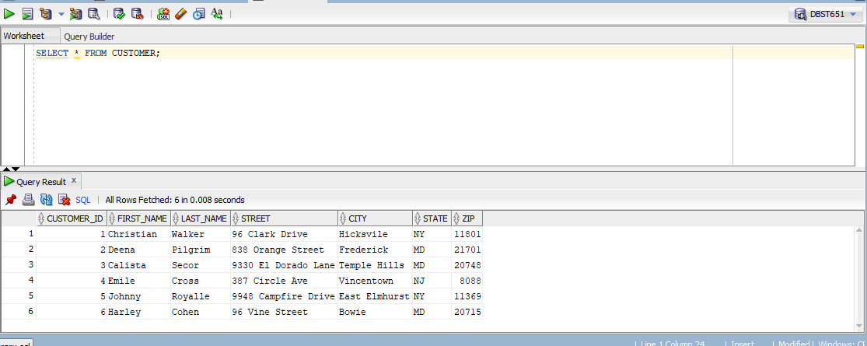

2.

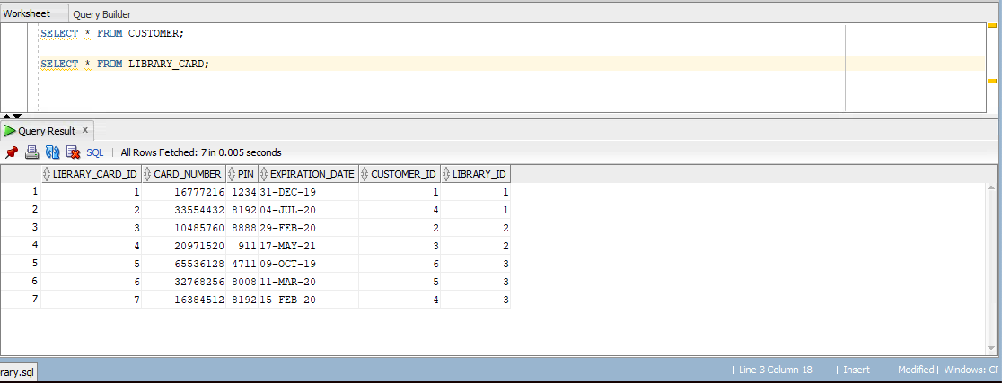

3.

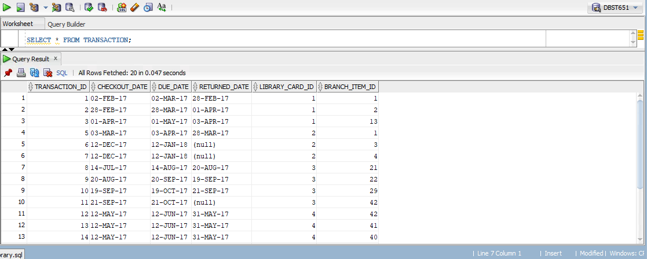

4.

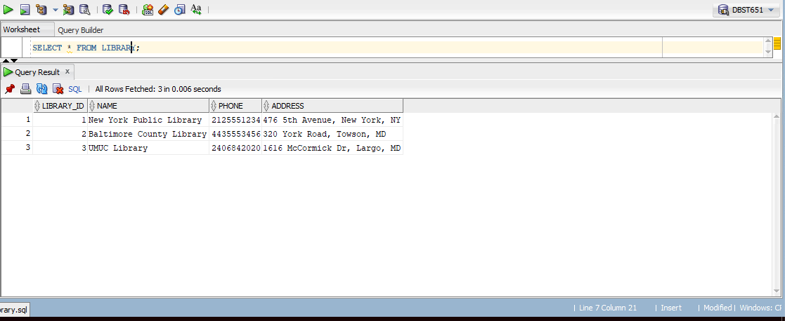

5.

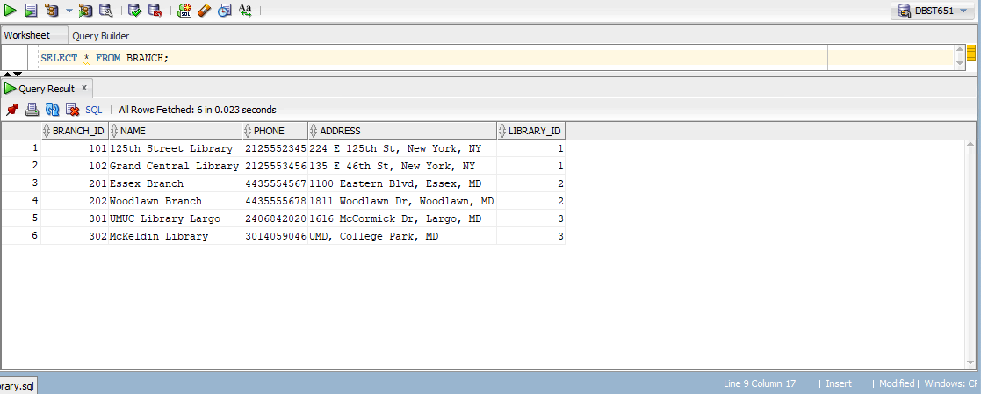

6.

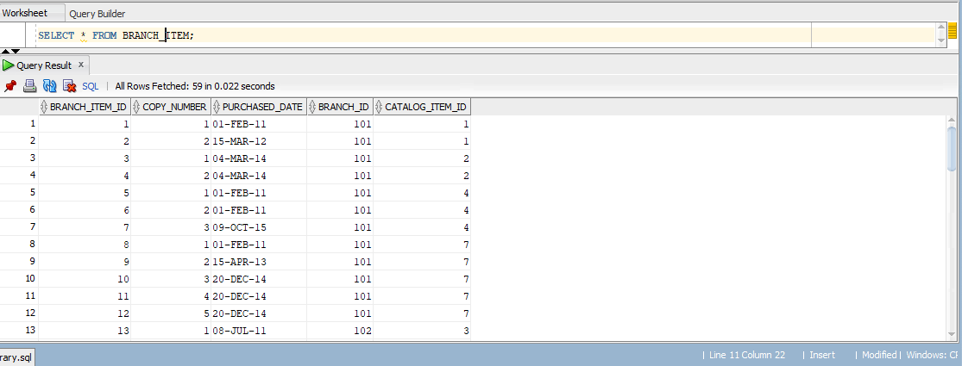

7.

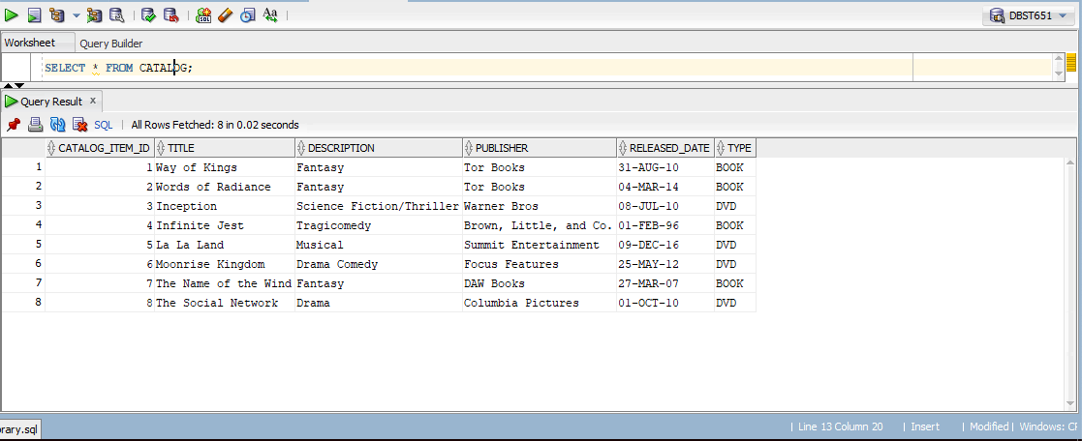

8.

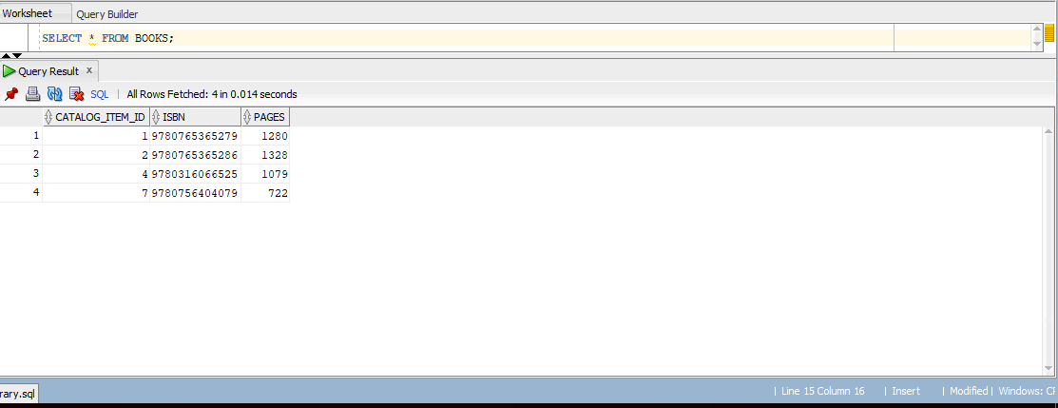

9.

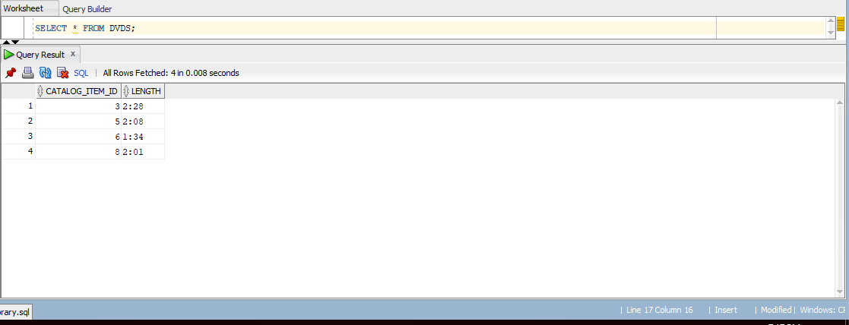

QUERIES

1.

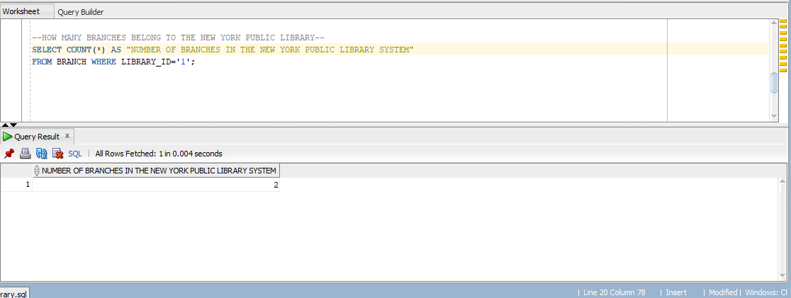

2.

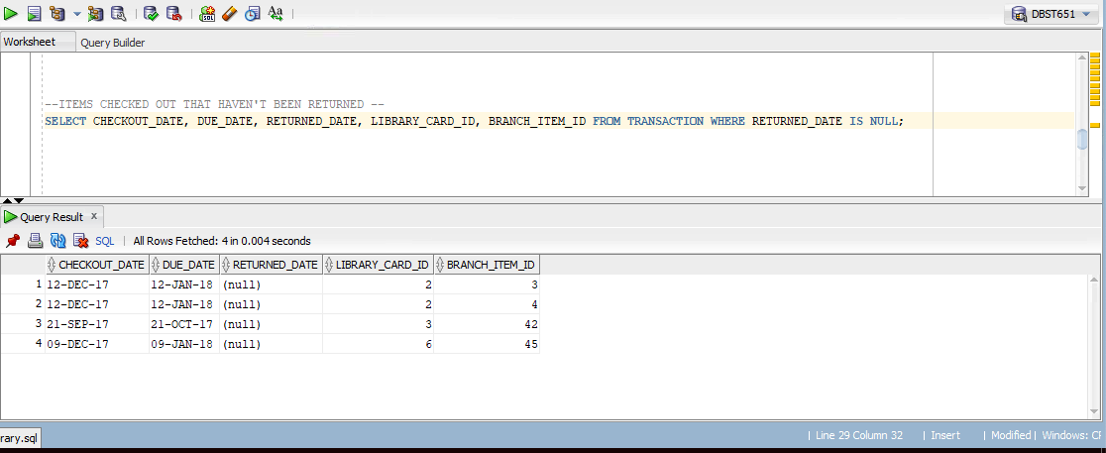

3. 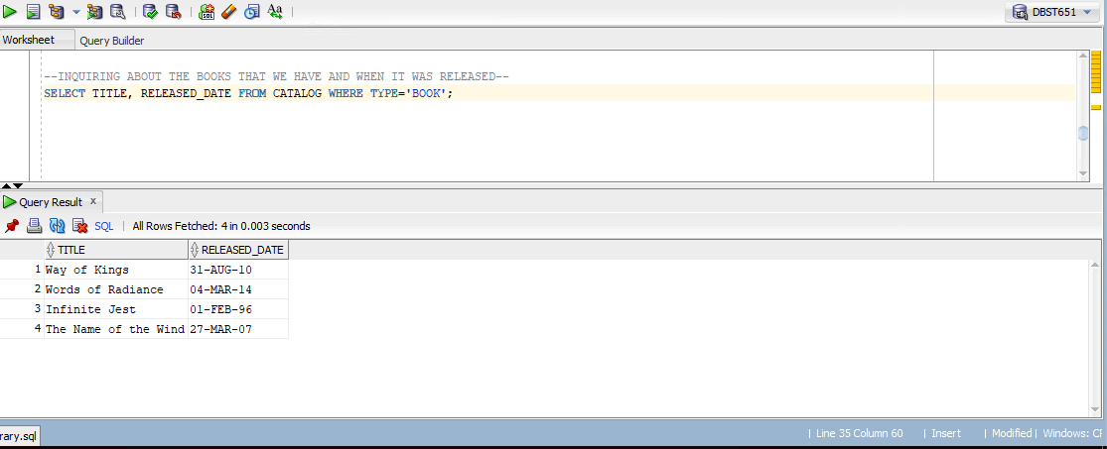

4.

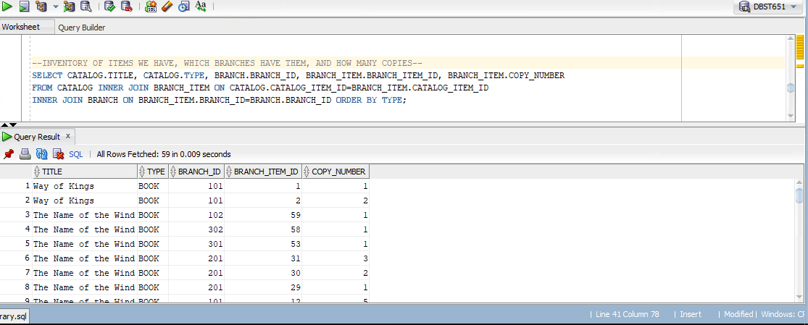

5.

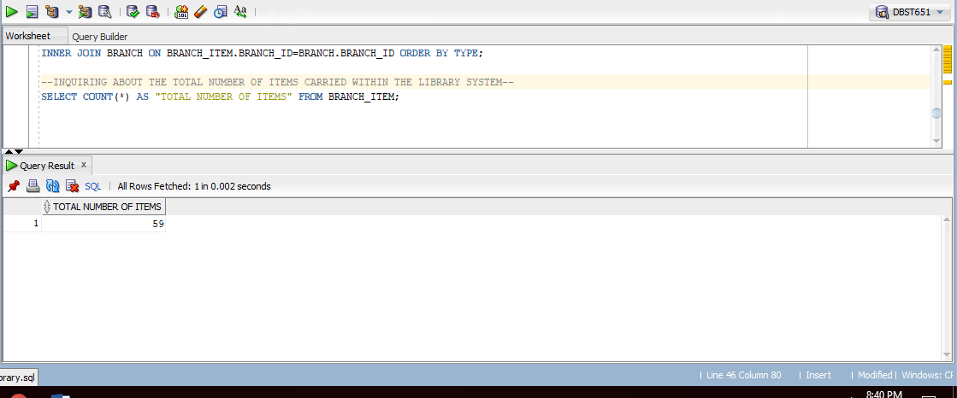

6.

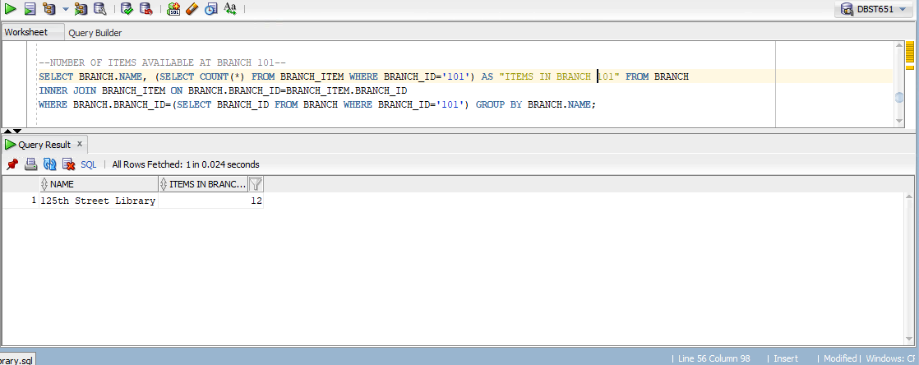

7.

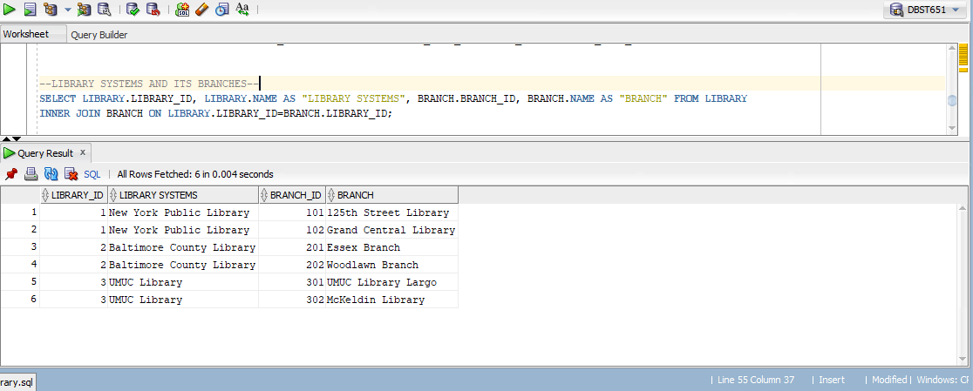

8.

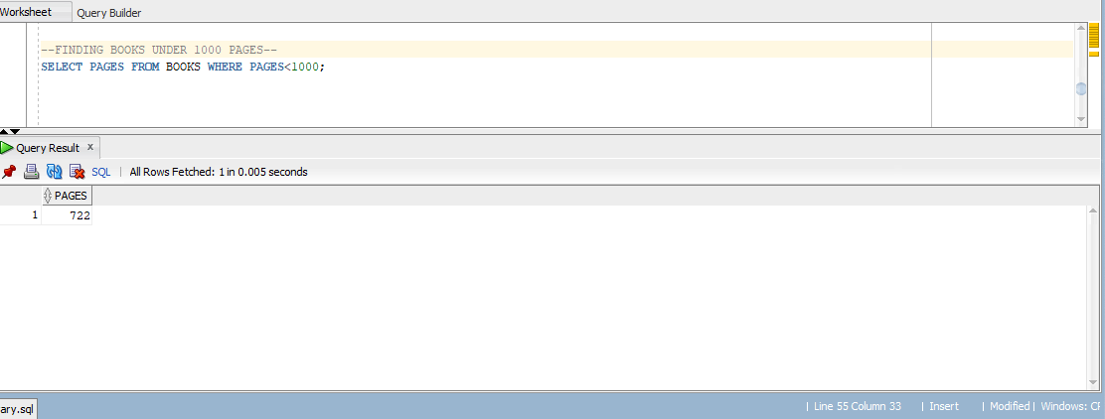

9.

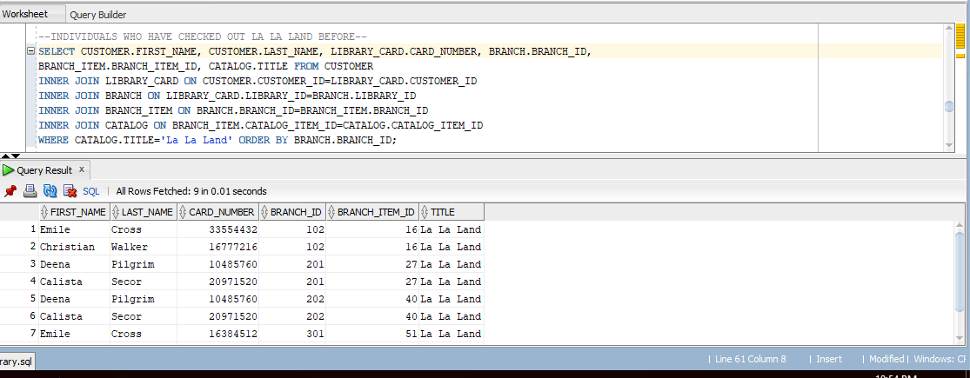

10.

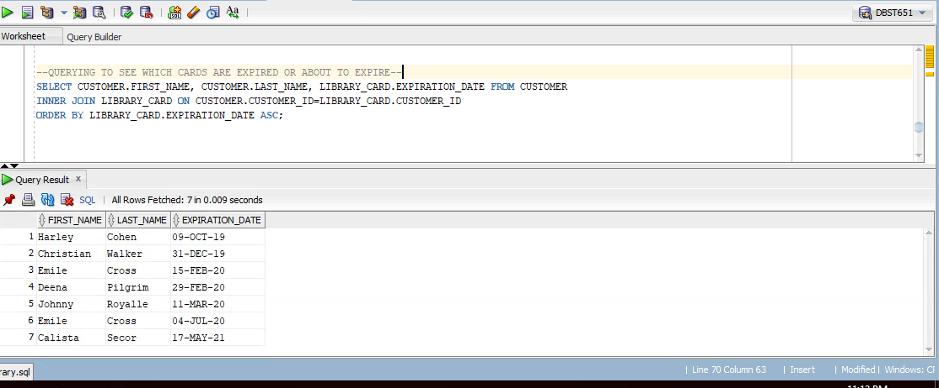

11.

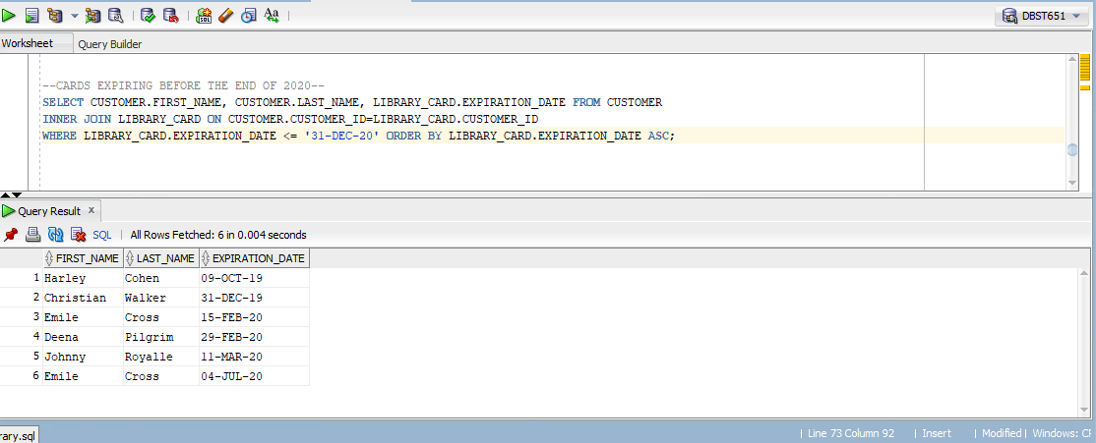

VIEWS

